SOCIAL POLICY ECOLOGY RESEARCH INSTITUTE - SPERI
Yearly Narrative Report
July, 07-June, 08

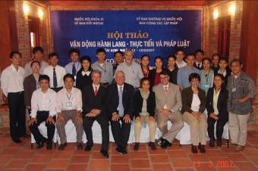
Department of Foreign Cooperation - DEFO
1/8/2009

SPERI is in the reforming; and therefore, all departments including Department of Foreign Cooperation (DEFO) are taking steps towards transforming themselves.
Introduction

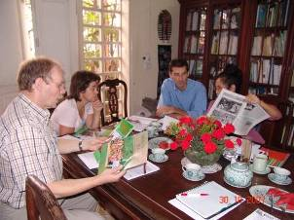
The old approach was that DEFO operated in the single-department oriented. Little efforts were made to build linkages/connections with other departments within SPERI. Lacking of cross-departmental communication was clear, and that working-overlaps were evident. An ability to optimize human resources among departments was unconcerned.

In the latest year, SPERI’s reform defined the new approach i.e. more inter-departmental sharing, improvement in cross-departments communication and networks, and put focus on improvement of Farmers Field Schools’ learning-teaching-training services. Given this new setting, DEFO has learnt to professionalize itself not only to meet the needs of SPERI, but also transforming into a professional cooperation services, proposing reliable international researching-training contacts for the FFSs networks.

For the long term, DEFO expected to build capacity towards:
- Long term connections and partnerships with key actors (e.g. global FFS, key research institutes such as Australian National University (ANU), Regional Center for Social Studies and Development (RCSD)-Chieng Mai Uni, Thailand, National University in Island, leading political science institute e.g. Ho Chi Minh political academy, active youth-civil society movement e.g. TVS, Mekong-scale farmers networks) and media networking; and
- Looking for extra reliant supporters who should be in-line with ICCO’s vision, having similar commitments with SPERI in the cause towards addressing better grassroots empowerment.

For the short term, DEFO aimed to professionalizing itself in:
- Professionalize developmental administration (i.e. service-based in logistics, visa arrangement, working schedule, and other housekeeping matters);
- Strengthening the current contacts, networks, and partners; and
- Continue looking for and suggest good contacts to the FFSs networks.

DEFO activities have been diverse throughout the months. We were most busy in July-07, Oct-07, and Jan-08; and fewer contacts in Sept-07, and Dec-07. Contacts in July, Oct, and Jan were more of the many smaller contacts; and yet, the ones in Sept and Dec involved more as the DEFO key partner activities.
DEFO and its Performance of Tasks

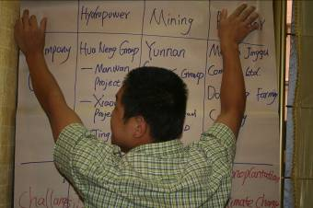
Contacts in-and-out and also to-and-from DEFO were in a long spectrum ranging from individual interests such as permaculture volunteers to more groups of visitors (e.g. the Korean group, the Asian youth groups, and the ANU students group). There were numerous contacts at the high level, formal and well-structured policy level (such as ADB meeting, Policy Lobby, DANIDA, and AYAD, and so forth).

See more in Annex 4: Table 2- List of the DEFO activities per month (July, 07 - June, 08) and Figure 6: Overview of DEFO activities from July 07 to June 08 for illustration (see annex 4). See also Annex 1: Detailed list of DEFO activities for July-December 2007 and Annex 2: Detailed list of DEFO activities for January-June 2008 for more details.

In sum, there were 95 contacts: 47 activities are completed; 27 activities are open for ongoing and/or potential (depending on future direction of SPERI). There were 5 activities that had no one to follow up (no human resources available); and about 16 activities that did not happen (no outcome although time and resources were invested) - see annex 3 & 6.

Activities that are completed

Given the 47 DEFO activities that are completed DEFO has summed up into three key functions that DEFO had successfully done.
- Together with DAD well-manages professional administrative assistance to varied service-receivers;
- Builds significant linkages with other departments in SPERI, mainly DES and DELOBBY, to promote active social contributions; and
- Well-maintains the current social networks, and therefore facilitating social changes.

Professional administrative assistance DEFO-DAD

Despite a long-list of providing administrative assistance to individual contacts (the largest group is permaculture volunteers of Permaculture Research Institute (PRI), Australia, second is the key leading scholars in the Asian), and serving a number of groups’ contacts (including ICCO, RCSD); the very key achievement was DEFO outsourced its professional administrative skills to assist the 2nd International Policy Lobby Conference (with CODE), and the Conference went well. Besides, DEFO finished its regulations (in Vietnamese and English) after a series of inter-departmental discussions and consultation.

Inter-departmental supports DEFO-DES-DELOBBY

SPERI/DEFO-DES signed a contract with AIPP on the Project of translating Indigenous Peoples materials into Vietnamese and getting them disseminated. Among many materials, DES finished translating the UNDRIP (United Nation Declaration on the Rights of Indigenous Peoples) in Vietnamese, and together with DEFO shared this resource to key policy-makers, get it published in the Literature and Ethnicity Magazine.

DEFO kept contacts with Veerle Vandenhende (SPERI’s advisor on Sustainable Development) to complete the Book about SPERI (it compiles of 10 chapters and currently looking for a reliable publisher). DEFO also assisted enormously the Scuba Vision Film Crew, and the Crew will be finishing one introductory and the three in-depth film components soon. The film reflected the works of SPERI with indigenous grassroots in many facets. The introductory part was released on YouTube for temporary use; and the much completed versions will be out soon.

DEFO was very supportive in helping DES in improving Research and Development (R&D) capacity through strengthening the current networks (e.g. AIPP, ANU). The connections with the Australian National University (ANU lecturer and students) have been extended; and there were three levels of connections. One contact was from a group of 14 ANU students paid a visit to Farmers Field School-HEPA on learning local culture, indigenous practice in preserving the forest through worshiping ceremony, and also explored farm economy at the farmer-scale. The other contact was the two-weeks intensive teaching (voluntary teaching) from an ANU student but currently on exchange to University of Virginia, USA. This student has built on enormous aspirations to the FFSs’ minority students on International Environmental Issues and integrated with English language. The latest visit was from Prof. Richard Baker who paid himself a brief visit to SPERI to share about Land Care experience, Land Care as social movement, land degradation is not an easy and quick technical fix; it must be built from the social changes, and addressing from the social solutions.

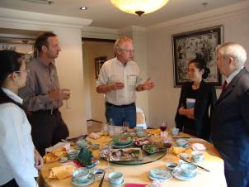
With DELOBBY, as part of the SPERI’s theme on continuity on the path to empowerment; DEFO gave full supports to all staff members (junior and senior alike) in applying to attend international events, workshops, and conferences. One junior staff went to the Philippines to attend the UNDP HRBA Training, Philippines (financed by UNDP); one junior staff attended the 5th Roundtable on Sustainable Palm Oil (RSPO), Malaysia (financed by RSPO organizing committee in relation to Sawit Watch, Indonesia); one junior staff attended the Gross National Happiness Conference, Thailand (financed by Gross National Happiness (GNH) organizing committee in relation to Thailand Volunteer Services (TVS); and one senior staff applied to Mekong EarthRights School (though application failed).

The most significant achievement between DEFO and DELOBBY is the facilitation and/or organization of meetings between key SPERI senior to attend high-level talks and/or consultancy groups. DEFO arranged times and documentary preparation for DELOBBY to join: (a) Consultancy on the report on implementation of the UN Convention on the Rights of the Child, (b) Consultancy in the NGO meeting on ADB Safeguard Policy Update (focus on social impacts), (c) Consultancy with Inter-Embassies on Anti-Corruption Dialogue, and (d) Consultancy and information sharing with Oxfam NOVIB Meeting on Land Issues.

DEFO facilitates networking, cooperation, and changes-making

With maintaining the current cooperation DEFO maintains a fair cooperative manner with ICCO (joining the evaluative report, administrative/logistics assistance and reports). It has a fair connection with RCSD (in international workshop on civil society, assist in independent evaluation of RCSD alumni). DEFO well-cooperates with ADDA (organic farming network, youth’s capacity building on Training of Trainers (TOT) skills, linking youths to the market through Participatory Guarantee System). For the near future, DEFO will build closed connection with Institute of Social Entrepreneurship in Asia (ISEA), Philippines - proposal developed and SPERI will be a host for the 2nd international training on social entrepreneurship.

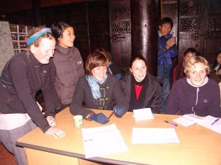
With maintaining the current networks, DEFO supports networking with TVS (through exchange and study trips with TVS and Asian youth groups (GNH, GPI Atlantic). In the future, the ties between SPERI/DEFO and TVS will be closer. DEFO also supported networking with KFEM (Korean visitors and their environmental networks) and would like to see more linkages to be built between young Korean and Vietnamese minority environmental activists. DEFO maintains fair contacts with the Australian Media Broadcast (Mrs. Jan Forrest). DEFO will continue keep linkages with Outer Voices, USA which stands for rights and positions of women over the World.

Activities that are on-going and/or potential
DEFO strongly sees that the 5 contacts are important and to a degree, of relevant to SPERI’s works, and strategies. It is important for SPERI to improve its Research and Development (R&D) capacity and gets all R&D to be raised in more international forum and arena. About 3 out 5 of this kind of contact are for development and (applied) R&D.

- The contact with Prof. Heather Goodall would be relevant for later SPERI’s publication on Conservation and Society as the works involved are very much focusing on cultural preservation for the targeted marginal indigenous groups.
- The contact with Mr. Van Hall on vocational technical college, The Netherlands (after Margreet’s establishment) is though a bit distant; nevertheless, might offer a good exchange on agricultural techniques and exposures to the bigger picture between the farming context in the Netherlands and the one in Vietnam.
- The contact with Japanese Prof. Takaaki Niren on Eco-community would be good for the Human Ecology Village Network but yet at the current stage might not be overloading. The reconnection with Prof. Takaaki Niren on Eco-community should be done in the near future when the shapes of all villages that SPERI has been working with are better transforming towards Human Ecology villages.

There is a contact with Karin van Veen on small scale producers (from the weaving network) which was a great opportunity. Contact with Karin would be a good chance for linking indigenous female weavers to the market (good for handicraft network MECO-ECOTRA); but due to the lack of capacity (e.g. English, coordination skills, marketing skills) of the handicraft coordinator that SPERI seemed to miss this contact.

Activities not happen
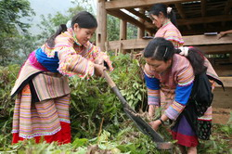
Received emails about 6 members from permaculture network and volunteers. Most were writing to DEFO with prior commitments of offering voluntary works but due to reasons e.g. changing of times, shortage of finance, and etc so therefore cancelled. Therefore, addressing issues towards volunteering network and voluntarism.
Received a contact from Action Aid about introducing 2 peace volunteers in the field of peace and conflict transformation but did not work out neither. Therefore, addressing issues towards peace building networking through giving opportunities to international youth voices and share SPERI’s approach and experiences.
Was asked to make the most effort in making applications for the 2 representative minority elder healers to attend the Canadian Conference. This was one of the outcomes from the 3rd Indigenous Knowledge and Biodiversity Conference in Lijang i.e. a call for indigenous applicants to attend the Canada Conference on International Indigenous Expert Consultation on Access and Benefit-sharing Conference in Montreal, Canada 19-21 September 2007. If the 2 indigenous applicants were successful, then SPERI might facilitate the reach of the 2 aims (1) to integrate indigenous voices in the international forum, and (2) to empower the elderly healers by assisting them in gaining exposures at international level (issues and the big picture). DEFO has not heard even 1 reply from Conference organizer. Therefore, addressing issues towards bureaucracy of international mechanisms towards respecting indigenous applicants.
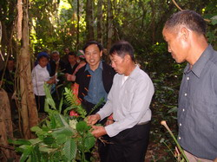
Received a plan about a group of participants (relate to FORD project on land degradation and rehabilitation) proposed to meet SPERI and wanted to see a potential for SPERI-FFSs to become their practical study sites on land uses. A few key professors and actors made visits to FFS-Dong Le (in Quang Binh province), and to FFS-HEPA (in Ha Tinh province) – Central Vietnam; but since then, no news came out. Therefore, addressing the probability in establishing new partner in applied R&D.
Received an invitation to attend SROI Trainers' Training on May 19-23, 2008 (from mdacanay@aim.edu) Trainers' Training on Social Return on Investment (SROI) shall be sponsored by Oikocredit. SPERI was interested but did not have any human resource to attend. It is important for SPERI to define if it moved towards the social entrepreneurship as to promote further cooperation with ISEA. Therefore, addressing the possible R&D training and exchanges in areas of social enterprises with ISEA (Institute of Social Entrepreneurs Asian).
Received a contact from Thailand (after the Regional Dialogue on Indigenous People rights and Nantural Resources Management) sent an email to DEFO on a possible visit to FFSs to establish dialogues with minority students on "Political Economy and Impacts from Globalization in the 21st century” (sum would be 40 participants, 36 students and 4 Professors) but did not work out due to time limits. Therefore, addressing that this type of opportunity should be promoted but seemingly due to workloads that SPERI/DEFO missed out this chance.
Received a contact from Rene Magermans-ETC Energy, The Netherlands (r.magermans@etcnl.nl) on small scale energy production (small hydro dams) was shortly established but did not turn out into a project. DEFO informed a senior SPERI colleague and that he got quite involved but nothing worked out. Therefore, addressing that before any more commitments should be engaged, the prior phase of surveying and understanding the project, scope, and areas of shared interests should be as clear as possible.
Arranged for a permaculture volunteer, Mrs. Ruth Moss to bring some handicraft products (from handicraft network) to exchange in USA (maybe set up a handicraft coop) for people back in the USA but heard no replies yet from Ruth. Therefore, addressing the need to follow this up.
Got a contact from water and adaptation in Huong River basin (email from Annelieke Douma ad@bothends.org; Dutch NGO Both ENDS; ADAPTS is a project Both ENDS developed together with IVM and the Dutch ACACIA Institute. A meeting was arranged but did not work out.
Has worked together with other departments to arrange the Speaking Tour for Indigenous Elder Jonny from Thailand civil society and indigenous movement but due to other work plans took up higher priority so the Tour has not yet been happened. Therefore, addressing the need to follow this up.

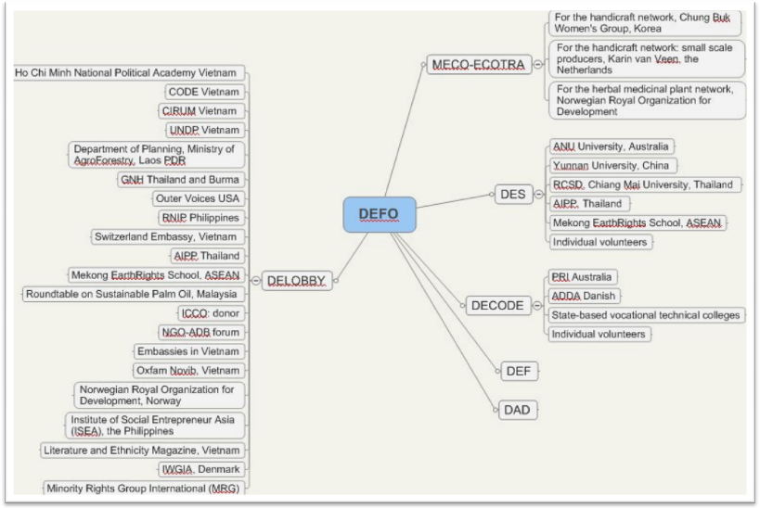
DEFO promotes cooperation for other departments
Figure 1: DEFO promotes international cooperation for other departments in SPERI (July, 07 - June, 08)

DEFO in relation with MECO-ECOTRA regional farmers networks

Finding outcomes for MECO-ECOTRA network has always been in the top priority in DEFO’s thinking. Outcomes here if looking from the market angle (i.e. more in-line with social marketing, i.e. getting the names of MECO-ECOTRA and their associated products to reach larger audience e.g. herbal medicinal plants, fully natural handicraft products). What makes MECO-ECOTRA’s produces so special are probably the produces are attached with a great sense of self-proud, ethnic identity and strong attachment of cultural value and sense of belonging.

DEFO found the three contacts that would be of useful for MECO-ECOTRA. These are (1) Chung Buk Women’s Group in Korea, (2) Small scale weaving producers from Karin van Veen from the Netherlands, and (3) the Norwegian Royal Organization for Development for the herbal products. The three contacts have not yet seemed to work out. This could be due to the capacity of SPERI coordinators (lack of human resources).

DEFO in relation with DES

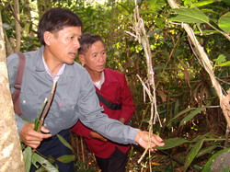
Development Studies is the key department that produces key ideas and thoughts into the future direction of SPERI. DEFO is aware of this, and hence, has worked tightly with DES in promoting any cooperation(s) that are worth in reaching the aims of SPERI.

There have been 6 lists of DEFO contacts that were brought to DES. Among those, possibly the connections with the Australian National University (ANU), and also Asian Indigenous Peoples Pact (AIPP) Foundation (Thailand) were the strongest and most successful connections. Together with DES, we maintain occasional contacts with RCSD (e.g. one International Workshop on Imagining Civil Society was successfully organized with 20 key minority healers in the Asian region (including Laos); and the 3 leading Thailand scholars (one from Harvard school).

DEFO assisted one DES staff to send application to the Mekong EarthRights School, ASEAN scale; yet, the application failed. We expect to follow this up in the future. The contact with Yunnan University on presenting a paper on Impacts on Tourism to IPs communities; though SPERI could not organize any one to attend, yet SPERI introduced Mr. Tu, the CODE’s director to attend on behalf of our SPERI-CODE alliances. DEFO received a number of individual volunteers who expressed their willing in working with/for DES but DEFO could not find enough human resources to work with, so simply did not really succeed in this scale.

In short, over the last year, DEFO has done fairly okay with building the connections for DES. In the future, the possible focus might be continuing with ANU, AIPP, RCSD, and possibly Mekong EarthRights School.

DEFO in relation with DECODE

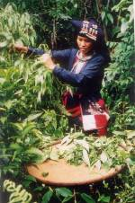
DEFO has well established the 3 main contacts for DECODE including Permaculture Research Institute (PRI, Australia), ADDA (Danish Development Aid), the Lao Cai state-based vocational technical college, and many individual volunteers.

The connection with the PRI Australia has been very strong. This cooperation has nurtured in many forms: from PRI leadership level who conducted a series of training on Permaculture in Practices courses, to continuous contacts from Permaculture Volunteers. At the PRI leadership level, Geoff Lawton has contributed enormous inputs in shaping the SPERI’s direction towards our philosophy ‘Nurturing the Nature’. Training courses ran by Geoff Lawton and his trainers have given aspirations to our MECO-ECOTRA farmers and also FFSs minority youths alike the dreams and commitments to move towards the Sustainable Farming Practices, at the farmer-scale level. In terms of Permaculture Volunteers, DEFO received more than 10 contacts for DECODE and many of them visited SPERI/FFSs practical training sites, and worked to contributing for SPERI on the ground. In the meantime, there are about 3 Permaculture Volunteers who are working in the Farmers Field School - HEPA.

The connection with ADDA has also been very active. The interests from ADDA have been to build more capacity for SPERI youths in TOT, in training on organic agriculture, and also in linking them to the market through the PGS (Participatory Guarantee System). ADDA has successfully supported the 7 minority youths from SPERI to join the 18-weeks long course on growing organic vegetables and are now in the process that these 7 youths continue to give training to their neighborhood farmers back in their community.

The connection with the Lao Cai State-based vocational technical college has been going so well with particularly Farmers Field School in Simacai. Not only the college shows interests in learning from the FFSs teaching and learning methodology, but also they asked FFSs to be their expertise providers in teaching methodology, on-site learning materials, and also young human resources (i.e. those youths who have graduated from FFSs). There are and will be continuing collaboration extended from this.

DEFO in relation with DELOBBY

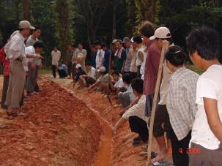
The linkage between DEFO and DELOBBY in the last year is the most successful. DEFO worked closely with DELOBBY in many tasks/functions. Given the one year, DEFO has assisted DELOBBY in coordinating with about 13 international cooperations. All of the contacts are important ones for DELOBBY to either work on consultancy at high policy level or sharing critical inputs reflecting implementation of laws to the policy-making processes. For instance, DELOBBY has actively involved in (a) Consultancy on the report on implementation of the UN Convention on the Rights of the Child (UNDP), (b) Consultancy in the NGO meeting on ADB Safeguard Policy Update (focus on social impacts) (NGO-ADB forum), (c) Consultancy with Inter-Embassies on Anti-Corruption Dialogue (Embassies in Vietnam), and (d) Consultancy and information sharing with Oxfam NOVIB Meeting on Land Issues.

DELOBBY had contributed enormously in writing up at least three concept papers (1) the first herbal project to Switzerland Embassy, (2) the second herbal project to the Norwegian Royal Organization for Development, and (3) the third paper to the Institute of Social Entrepreneurship in Asia (ISEA). The first two concept papers have not yet succeed but the third one with ISEA was successful. SPERI will be the host organization in 2009 as a Pilot Regional Training on Social Entrepreneurship and the Market (Year 2) (proposed host: SPERI/Vietnam) in one of the Module Developments under the section: Capacity Development of Social Enterprises in Asia.

DELOBBY connects with AIPP regularly in terms of information sharing and getting involved in International Dialogues on Indigenous Peoples rights issues and NRM issues. DELOBBY has established a formal relationship (through a MOU signed) between SPERI and the Ho Chi Minh National Political Academy. Representatives from the Political Academy have been invited to attend the International Workshop on ‘Imagining Civil Society’. In addition, a series of SPERI’s publication on the grassroots democratization, civil society building, social capital, the new approach towards learning-by-doing through examples of Farmers Field Schools (FFSs) from the Literature and Ethnicity Magazines have been disseminated to the Political Academy lecturers and expect these resources will be used in their lecturing hours.

In short, DEFO and DELOBBY had a very busy one year from July, 07 till June 08. The effects and impacts from their works should be mentioned with great honor though they invisibly appear. It is both DEFO and DELOBBY who facilitate the positive changes-making, whilst strengthening the networking/cooperation with many actors in the society, both in Vietnam and abroad.

Commitments were made to ICCO about SPERI needed to seek one more new donor (for co-financing); SPERI has in fact not yet found the second donor. Given the scale of thematic programs and MECO-ECOTRA activities, it is a challenge for SPERI to continue addressing these questions:
Issues for discussion
- Re-defining working themes (i.e. agenda in development); Re-defining areas of focus (e.g. R&D, teaching and training, youth empowerment, farmers networking-linkages-empowerment); and also re-defining targeted partners for cooperation (e.g. development research institute, vocational training schools, social entrepreneurs institute, policy lobby institute? permaculture institute).
- Strategies to maintain the current activities (e.g. self-sustaining, or what makes SPERI so unique (what is the typical product that SPERI could make benefits out of it, and how links with MECO-ECOTRA; and/ or who would be appropriate new partner).
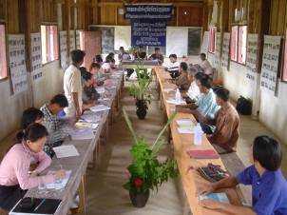
Development context in Vietnam is crazily changing; and its level of complexity is high. Witnessing the continued flows of financial institutions, MNCs, and more visible presence of conflicting agendas set by many players/actors; it becomes an extremely high challenge for SPERI to think about either reducing the number of contacts (i.e. in relation to re-defining agenda in development); strengthening only those cooperation that are in-line with SPERI’s vision; and for certain that, to promote one goal at a time with firm steps and be built surrounding by regional and international supports/networks/alliances aim at reaching the same goal as SPERI.

There is a critical debate among SPERI staff about should or should not SPERI become a service provider or just focus on consultancy. As the current manager of DEFO, the subjective judgment would be if on the road for SPERI wished to see itself to become a professional organization, then some preliminary steps should be to go through a service-based organization: not only DEFO needed to professionalize ‘service-based’ skills but holistic organization-wide should integrate aspects of a service-based organization, and for certain that, SPERI should always remain to serve our target groups i.e. marginal communities including farmers’ networks and minority youths.

SPERI is in the reforming, and development context is quickly changing. More cooperation will be required, but important for SPERI to redefine its focal linkages, targeted partners and cooperation, areas/themes of working per cooperation, and also financial co-responsibility. See Figure 2: Possible linkages Figure 2: Possible linkages , Figure 3: Possible targeted partners and cooperation, Figure 4: Possible areas/themes of working per cooperation, and Figure 5: Possible shared financial responsibility as some draft suggestions from the current manager.
Suggested models of cooperation

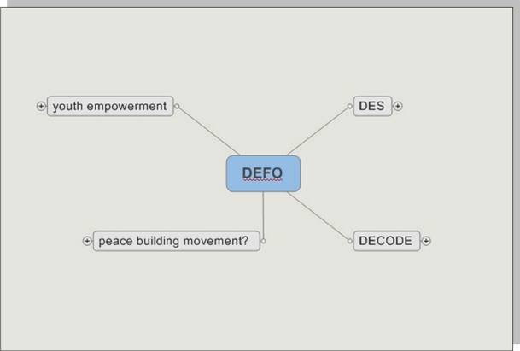
Figure 2: Possible linkages

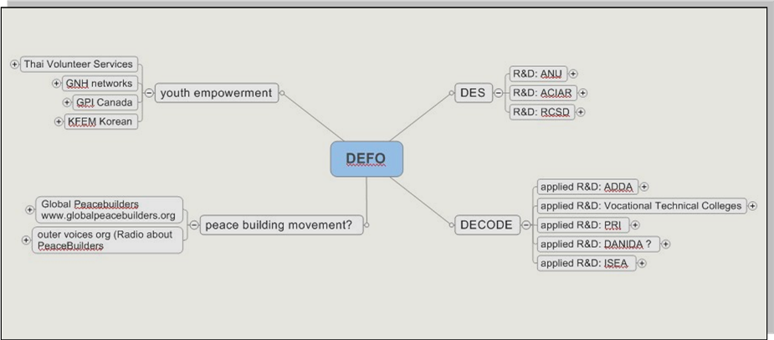
Figure 3: Possible targeted partners and cooperation

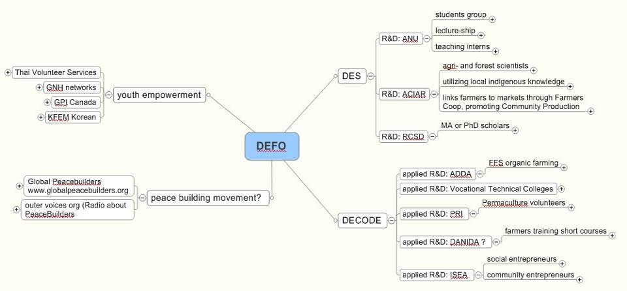
Figure 4: Possible areas/themes of working per cooperation

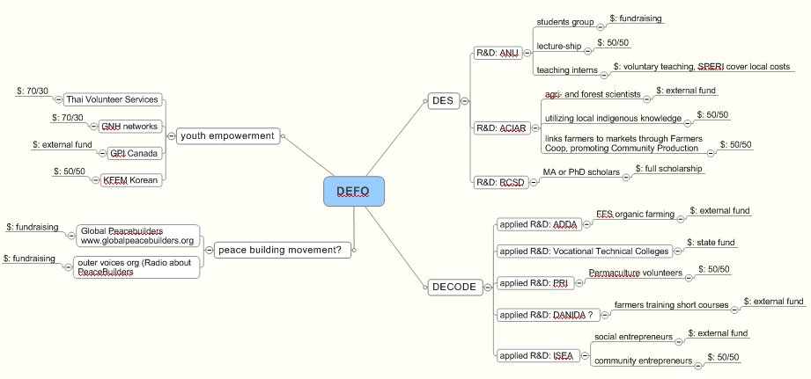

Figure 5: Possible shared financial responsibility

Annex 1: Detailed DEFO activities July-December 2007
Annex

 | DEFO  activities | Reflecting  What purpose? | Status of operation
JULY
1 | Peace Volunteers for SPERI (through contact with Action Aid): 2 young people from the European Peace University (field of peace and conflict transformation); Pooja is from the US, originally from India and Zaheer from Pakistan | Peace volunteers for youths | Not happen
2 | Participate at 3rd Asia Conference on Indigenous Knowledge and Biodiversity, Lijiang Yunnan | Networking with alliances on IKB | Maintain network with AIPP
3 | Translation materials with AIPP (IPs materials) | Capacity building and knowledge sharing on IP issues (rights) | Contract till end of 2007
4 | Sending indigenous applications to (International Indigenous Expert Consultation on Access and Benefit-sharing Conference in Montreal, Canada 19-21 September 2007) in Canada Conference, September 2007 for Elder Cau, Elder Tuyen | Minority empowerment, follow up 3rd IKB conference | Not happen
5 | The Book writing about SPERI | Collection, publication and dissemination about SPERI’s works | Complete in 2008
6 | Filming SPERI’s activities (in cooperation with Scuba VISION) | Publication and dissemination about SPERI’s works | Complete in 2008
7 | Voluntary work from Ms. Campbell Wilson about Permaculture Design Course (2 weeks) | Permaculture network and volunteers | Not happen
8 | Visit of Prof.Chayan and Ajarn Chusak, Chieng Mai Uni. Thailand to SPERI | With RCSD | Maintain irregularly
9 | Establish links with Eco-Link for system of internal control with organic products due to the requirement of IFOAM. | With ADDA, organic farming network | On-going
10 | Contact from Tanzi PhD candidate on Exploring Ecological Frameworks for Sustainable Communities. Introducing to Professor Heather Goodall. Heather is the editor of a journal called Conservation and Society and they are enthusiastic to have more papers from Vietnam included in the journal. | For R&D (Australian network) | Not follow-up
11 | Visiting by Outer Voices 2007 |  | Ongoing
AUGUST
1 | Logistics preparation for Ruth Moss and Marisha (visiting permaculture sites in Vietnam) | Permaculture network and volunteers | Complete in Feb 2008
2 | A group of participants (FORD-related) would like to visit FFSs as to see the potential of FFS to be their practical study site on land uses | R&D for land degradation, and local solutions to rehabilitation | Not happen
3 | Switzerland Embassy proposal (Networking action on traditional herbal knowledge). Expected to be a direct donor for Herbal Medicinal Network |  | Concept paper failed
4 | Exposure trip to Chieng Rai and Chiang Mai, Thailand for learning traditional medicine and community forest management from Hmong and Karen ethnic minority groups. | SPERI’s minority healers network, with TVS support | Completed
5 | Mr. Cao Dung (Ma Lieng minority) from MECO-ECOTRA and Mr. Pham Van Dung (senior SPERI) being part of the Conference on the IPs rights organized by Regional Network for Indigenous People (RNIP) | Minority empowerment, RNIP network | Good impacts
6 | Voluntary work from Mr. Doug Campbell, Australian for permaculture in HEPA and Quang Binh programs | Permaculture network and volunteers | Not happen
7 | Small scale producers in Vietnam (from weaving network) (referred to email communication with Mrs. Karin van Veen kvveen@planet.nl , The Netherlands for the handicraft network) | Seeking markets for handicraft networks
SEPTEMBER
1 | Planning TVS team visiting SPERI (logistics, and presentation introducing about SPERI’s works) | Networking with ISEAN civil society and volunteering organizations | Ongoing
2 | Initial contacts with Dr. David Sogge - an independent assessor (logistics preparation, etc) | For ICCO Evaluation in Vietnam | Complete in November 2007
3 | Initial contacts with Mrs. Catherine Dolleris - Counsellor Development, Embassy of Denmark | DANIDA is the bilateral program | Potential
4 | Prof. Richard Baker (ANU) visiting and sharing about Land Care movement | For R&D (Australian network) | On-going
OCTOBER
1 | ICCO evaluation in Vietnam (David and Dr. Nghiem Huong); | For ICCO Evaluation in Vietnam | Complete in November 2007
2 | Receiving Korean visitors (KFEM) | Networking with Korean environmental organizations KFEM. | Completed.
3 | Invited in the meetings from consultancy groups for preparation of ARD SPS/DANID (Embassy of Denmark on two issues: 1- Designing Monitoring and Evaluation; and 2- Training Needs Assessment) | For consultancy (involvement of senior SPERI) | Potential
4 | Involved with Registration for Organic market in Tam Dao National Park, Hanoi. | With ADDA | Completed
5 | Consultation workshop for Report on implementation of the UN Convention on the Rights of the Child on 18 October 2007 | For consultancy (involvement of senior SPERI) Madame Lanh | Completed
6 | Distribution of conventional rights of IP (UNDRIP) | Information dissemination | Completed
7 | Publish approaches and turn the world's attention to what you're doing for peace - send Global Peace builders your approaches now and we will publish them (Action Asia < ActionAsia@online.com.kh> We will also publish the catalogue on www.globalpeacebuilders.org | Peace building movement and sharing stories | Potential
8 | Participate at UNDP HRBA Training in Philippines - Agenda, Transportation to Baguio City | Empowerment young staff member i.e. Nguyen Hong Anh | Completed
9 | Discuss details on the TOT participants and places for future FFS | With ADDA | On-going
10 | Logistic preparation for the RCSD-Chieng Mai Uni. training courses for SPERI’s taff happened in Vietnam | With RCSD | Completed
11 | Take part in the ICCO evaluation workshop Hanoi 31 October | With ICCO | Completed
12 | Final report of conference Social Marketing for organic products | With ADDA | On-going
NOVEMBER
1 | SPERI colleague attended at the RSPO Conference in Malaysia | Empowerment young staff member (exposed to bigger picture: biofuels, energy security) | On-going
2 | SPERI colleague attended at the GNH movement, Thailand | Empowerment young staff member (exposed to civil society-youth building, happiness spreading, local solutions to address happiness indexes) | On-going
3 | Involved with Study for Law on Implementation of Anti-corruption | For consultancy (involvement of senior SPERI) Madame Lanh, and key ambassadors | On-going
4 | Sending biofuels information to Mrs. Helene and Henk - ICCO | Share information to ICCO | Completed
5 | Logistics information for the trip to visit at Family Enterprise on Herbal Medicine and Mesamai, Thailand | For promoting social/family entrepreneurs (SPERI seniors) | Completed
6 | Logistics preparation for the Regional Dialogue on Indigenous Peoples and Natural Resource Management, Chiang Mai, Thailand - Workshop Guide for the former head of Minority Council of the Vietnamese National Assembly (Mr. Cu Hoa Van) | Regional dialogue on IP rights issues | Completed
DECEMBER
1 | Trip to Regional Dialogue on Indigenous Peoples and Natural Resource Management, Chiang Mai, Thailand (for Mr. Cu Hoa Van, Madame Lanh) | Trip to Regional Dialogue on Indigenous Peoples and Natural Resource Management, Chiang Mai, Thailand (for Mr. Cu Hoa Van) on | Completed
2 | Logistics for meeting with Shelina Thawer, Regional Programme Coordinator – Asia & Pacific, Minority Rights Group International (MRG) through Colin Nichols in Malaysia (issues: lobby against mega-dams projects) | Follow up Regional Dialogue on IP rights | Completed
3 | Logistics preparation for the 2nd International Lobby Conference (helping CODE) |  | Completed

Annex 2: : Detailed DEFO activities January-June 2008

 | DEFO  activities | Reflecting  What purpose? | Status of operation
JANUARY
1 | Mrs. Jan Forrester - an Australian volunteer participating in the 2nd international lobby conference and also FFS-HEPA | Networking | Completed
2 | Follow up with Herbal Project by Norway Organization, Mrs. Tran Thi Kim Chi (for herbal medicinal networks) |  | Ongoing
3 | Meeting with ADB and NGOs (on the development of the ADB Safeguard Policy revision, and also in engaging in ADB policy and investment operations in Vietnam, in the same way as other Vietnam-based Civil Society Organizations (CSOs) may have been exploring them) | For consultancy (involvement of senior SPERI) Madame Lanh | Completed
4 | Invitation to be at the NGO Meeting on ADB Safeguard Policy Update (SPU) process, January 29, from 8:30 to 15:00, at the NGO Resource Centre | For consultancy (involvement of senior SPERI) Madame Lanh | Completed
5 | Logistics preparation for Prof. Lisa’s trip to Vietnam (on social entrepreneurship) | With ISEA | Completed
6 | Invitation to attend Social Return on Investment (SROI) Trainers' Training on May 19-23, 2008 (from mdacanay@aim.edu) . Trainers' Training on SROI shall be sponsored by Oikocredit. This is in line with efforts to promote and build the capability of social enterprises to use various tools for measuring social impact | For R&D (on social entrepreneurship) | Not happen
7 | 14 ANU students visiting FFS-HEPA (learning and activities) | For R&D (Australian network) | On-going
8 | Meeting with Van Hall co the email: willibrord.verheggen@wur.nl (Magreet da moi Van Hall (technical college, learning by doing methodology, Van Hall sending students to practice organic agriculture in the FFSs | For R&D (Netherlands network) | No one follows up
9 | Contacts from Tee Jupoh teejupoh@yahoo.com about possible visits for “dialog with your student/ Institute concern Topic on " Political Economic globalization on 21st; all together total 40 participants, 36 students and 4 Professors | Follow up Regional Dialogue on IP rights | Not happen
FEBRUARY
1 | Contacts with Rene Magermans - ETC Energy r.magermans@etcnl.nl on small scale energy production (small hydro dams) |  | Not happen
2 | Sending Australian Youth Ambassadors for Development application forms | For R&D (Australian network) | On-going
3 | Logistics for Mr. Timo Kuronen, Finnish visiting FFS-HEPA from 8-10 March | Permaculture network and volunteers | Completed
4 | Invitation by Germany Embassy to Madame Lanh (on anti-corruption dialogue) | For consultancy | Completed
5 | 2 USA students visiting FFS-HEPA Marisha Auerbach and Ruth Moss (i.e. Mrs. Kim Chi) | Permaculture network and volunteers | Completed
6 | Ruth Moss brought some handicraft products to exchange in USA (maybe set up a handicraft coop) for people back in the USA | Permaculture network and volunteers | Not happen
7 | Involved in WiserEarth social network (introduced by Mrs. Marisha Auerbach) | Permaculture network and volunteers | Ongoing
8 | Logistic preparation for Madame Lanh (trip to EU) |  | Not happen
9 | Logistic preparation for Mr. Geoff and Nadia’s trip, PRI-Australia to Vietnam | Permaculture network and volunteers | Completed
10 | Visiting and training by Prof. Lisa (the Philippines) | With ISEA | Ongoing
11 | Cooperate with ADDA (sending 7 youths for TOT on growing organic veggies) | Empowerment for youths, with ADDA | On-going
12 | Elder Jonny trip to Vietnam (speaking tour) | IPs rights issues, networking with IPs leaderships | Not happen
MARCH
1 | Visit by Mr. Timo Kuronen (timokuronen@gmail.com) | Permaculture network and volunteers | Completed
2 | Cathrine Dolleris catdol@um.dk and Irene Christiansen (Senior Adviser, Department of Agriculture and Rural Development, Lai Chau and Lao Cai) irenechr@hotmail.com about establishing the cooperation with Danish Embassy (Danida supported ARD SPS program in Lao Cai and Lao Chau province, northern Vietnam. | DANIDA is the bilateral program | Potential
3 | Meeting with representative of Oxfam NOVIB (Mr. Henk Peters) on Land Issue | For consultancy (involvement of senior SPERI) Madame Lanh | Completed
4 | Visiting EU of SPERI’ director (Madame. Lanh) |  | Not happen
5 | Message from Miyoung (Fairtradekorea); Lee,Mi-young - Director, Korea Women's Environmental Network | For R&D (Australian network) | On-going
6 | Contacts from Presentation of Prof. Takaaki on Eco-community in Asia Takaaki Niren (niren@ses.usp.ac.jp) | For R&D (eco-community) | No one follow up
APRIL
1 | The Norwegian group to FFS-Simacai. |  | Completed
2 | Participate in the Participatory Guarantee System for the local organic market with Koen | With ADDA project | Ongoing
3 | Application to the Mekong School (Mekong EarthRights School) for DES member (Mr. Pham Van Dung) | For R&D (Mekong network) | Completed but application failed
4 | Connection with Epstein, Paul Robert paul_epstein@hms.harvard.edu friend from David Sogge | Follow up David Sogge’s network of friends | Completed
5 | Connection with Mrs. Lisa from Philippines (for Lanh or SPERI to become an incorporator of the Institute for Social Entrepreneurship in Asia -ISEA ) | With ISEA  Capacity Development for Social Enterprises in Asia.doc | Completed (proposal developing for 2009, 2010)
6 | Volunteering positions for Mr. Adison (Addison vu vu.adison@yahoo.fr) and Sawa (Sawa sourcream0826@hotmail.com) aimed to study Permaculture Experience in Vietnam | Permaculture network and volunteers | Not happen
7 | Volunteering Martina Boggian (martinaboggian@yahoo.it ) | Permaculture network and volunteers | Not happen
8 | Logistics preparation for Final draft itinerary for Henk Bakker’s visit in Vietnam April-May 2008 | With ICCO | Completed
MAY
1 | Logistics preparation and other paper works for Ambassador Scheme (AYAD) and SPERI to become an HO (Host Organization) | For R&D (Australian network) | Ongoing
2 | Logistics preparation for Ying Shan Lau (2 weeks intensive teaching at FFS-HEPA) | For teaching and training (Australian Singaporean network) | Completed
3 | Prof. Richard Baker shared ‘land care lecture on streamed video; http://fennerschool-lectures.anu.edu.au/lectures/SRES1001/week_09/lecture.php | For R&D (Australian network) | Completed
4 | Upgrade SPERI into Mekong University (discussions involved Mr. Kees, Prof. Chayan, Mr. Fulco and Madame. Lanh) | With RCSD, ICCO | Ongoing
5 | Dr. Ronald D. Renard, and evaluator of our center, Regional Center for Social Science and Sustainable Development (RCSD), Faculty of Social Sciences, Chiang Mai University. He will visit Hanoi, Vietnam on June 8 - 12, 2008 with the aim to talk with RCSD alumni and their employers. Aimed to evaluating RCSD works | With RCSD | Completed
6 | Program at Asia Society in San Francisco this October with Outer Voices (Mrs. Stephanie) (delayed for October) | With Outer Voices | Not yet happen
7 | Through RPI: Terry O'Shane (a very well respected Australian Aboriginal (indigenous Australian) elder) - ATT Permaculture staff, from Tropical North Queensland permaculture to show our project work in Vietnam | Permaculture network and volunteers | Not yet happen
JUNE
1 | Ms. Ying Shan Lau (2 weeks intensive teaching at FFS-HEPA: English and international environmental issues); finalizing teaching volunteer with Ying Shan Lau (exchange student from ANU and UVA) | For teaching and training (Australian Singaporean network) | Completed
2 | Upgrading SPERI in to MEKONG UNIVERSITY (continued) | For teaching and training | Ongoing
3 | The new book: Flexible Peasants: Reconceptualizing the Third World's Rural Types (sent by Ajarn Chayan) | For teaching and training | Completed
4 | Logistics preparation for international workshop on ‘Imagining Civil Society’ (organized in July 18-22) in collaboration with RCSD and Dr. Komatra (scholar graduated from Harvard Uni); | For R&D (with RCSD) | Completed
5 | The publication from IWGIA: the indigenous world 2008 | Reaching out IP voices | Completed
6 | Logistics preparation for Outer Voices revisit by August 2008 | With Outer Voices | Ongoing
7 | Water and adaptation in Huong River basin (email from Annelieke Douma ad@bothends.org; Dutch NGO Both ENDS; ADAPTS is a project Both ENDS developed together with IVM and the Dutch ACACIA Institute. |  | Not yet happen

Annex 3: Table 1: Analyzing the 47 activities the DEFO was well-performing (July, 07-June, 08)
DEFO key tasks done |  | Detailed
DEFO ADMINISTRATION (with DAD)
Administrative assistance at individual level | 6
 | 1 | Logistics arrangement for SPERI members to learn social/family entrepreneurs
 | 1 | Logistics arrangement for USA group (Ruth and Marisha)
 | 1 | Logistics arrangement for Australian group (Geoff and Nadia)
 | 1 | Logistics arrangement for Finnish single (Timo Kuronen)
 | 1 | Logistics arrangement for David Sogge's friend (Harvard person)
 | 1 | Logistics arrangement for Prof. Marie Lisa ISEA
Administrative assistance at group level
 | 3 | Administrative assistance for ICCO (David Sogge, Henk Bakker, Mary)
 | 1 | Administrative assistance for RCSD (Chayan, Chusak, Ronald D. Renard)
Administrative assistance at policy international policy conference level
 | 1 | Administration assistance for 2nd International Conference on Lobby Policy for CODE
INTER-DEPARTMENTAL SUPPORTS DEFO-DES-DELOBBY
DEFO Cooperating with DES
Capacity building - Knowledge Development
Capacity building, knowledge development, and information sharing on IP issues (rights) | 1 | AIPP translation materials
 | 1 | UNDRIP translation and dissemination
 | 1 | IWGIA publication
Information sharing with ICCO on biofuels | 1 | To Helene, Henk
Publication
Publication and dissemination about SPERI’ works | 1 | The Veerle's Book
 | 1 | The Filming SPERI (Scuba Vision)
For R&D learning-teaching-training | 1 | Students Exchange (ANU)
 | 1 | English and International Environmental Issues Teaching Internship with ANU
 | 1 | Land Care Lecturing Internship with ANU
 | 1 | Civil Society Workshop with RCSD
 | 1 | Publication
DEFO Cooperate with DELOBBY
Empowerment
Empowerment of IP voices | 1 | Ma Lieng minority involved in the International Conference - Grassroots Empowerment, with RNIP
 | 1 | HMong Minority Leader at the Policy Dialogue at ASEAN Regional Level, with AIPP and networks
 | 1 | Key Vietnamese Minority Activists at the Policy Dialogue at Asia and Pacific Regional Level, with Minority Rights Group International (MRG)
Empowerment for staff member | 1 | Junior SPERI staff attend UNDP HRBA Training, Philippines
 | 1 | Junior SPERI staff attend RSPO 5th, Malaysia
 | 1 | Junior SPERI staff attend GNH movement, Thailand
 | 1 | Application to Mekong EarthRights School, Thailand
Consultancy
For consultancy (involvement of high-senior SPERI) | 5
 | 1 | Report on implementation of the UN Convention on the Rights of the Child
 | 2 | NGO Meeting on ADB Safeguard Policy Update
 | 1 | Inter-Embassies on Anti-corruption Dialogue
 | 1 | Oxfam NOVIB meeting on Land Issue
DEFO FACILITATES NETWORKING, COOPERATION, AND CHANGES-MAKING
Cooperation
Cooperation with ADDA | 1 | Organic Market in Tam Dao national park with other NGOs
 | 1 | Facilitate 7 young minority youths attending TOT course on organic production in Xuan Mai University - MARD related
Cooperation with ICCO David Sogge | 1 | ICCO Evaluation in Vietnam
Cooperation with RCSD | 1 | Independent Evaluator to Evaluate RCSD alumni
Cooperation with ISEA | 1 | New proposal on social entrepreneurship
Networking | 1 | With TVS on trip for Mong and Karen minority healers sharing
 | 1 | With Korean visitors
 | 1 | With Australian media (Jan Forrester)
Potential partner | 1 | Norwegian group (herbal project)
 | 1 | DANIDA project (SPERI or FFS-Simacai to be service provider)
 | 1 | Switzerland Embassy (herbal proposal)

Annex 4: Table 2- List of the DEFO activities per month (July, 07 - June, 08)
Months | Number of DEFO activities | Activities
 | sum per month | maintain contacts, and/or completed | on-going or potential | Not happen | no follow up
July, 07 | 11 | 5 | 2 | 3 | 1
Aug, 07 | 7 | 4 |  | 2 | 1
Sept, 07 | 4 | 1 | 3
Oct, 07 | 12 | 8 | 4
Nov, 07 | 6 | 3 | 3
Dec, 07 | 3 | 3
Jan, 08 | 9 | 4 | 2 | 2 | 1
Feb, 08 | 13 | 4 | 5 | 4
Mar, 08 | 7 | 3 | 2 | 1 | 1
Apr, 08 | 8 | 4 | 2 | 2
May, 08 | 7 | 3 | 2 | 1 | 1
June, 08 | 8 | 5 | 2 | 1

Figure 6: Overview of DEFO activities from July 07 to June 08

Annex 5: Figure 7 - Performance of DEFO tasks delivery

Annex 6: Table 2 - Analyzing the 5 DEFO activities that had yet follows up
Month | DEFO activities that  had no one yet follows these up | In relation to what purpose?
July, 07 | Contact from Tanzi PhD candidate on Exploring Ecological Frameworks for Sustainable Communities. Introducing to Professor Heather Goodall. Heather is the editor of a journal called Conservation and Society and they are enthusiastic to have more papers from Vietnam included in the journal. | For R&D (Australian network)
August, 07 | Small scale producers in Vietnam (from weaving network) (referred to email communication with Karin van Veen kvveen@planet.nl for the handicraft network) | Seeking markets for handicraft networks
January, 08 | Meeting with Van Hall co the email: willibrord.verheggen@wur.nl (Magreet da moi Van Hall (technical college, learning by doing methodology, Van Hall sending students to practice organic agriculture in the FFSs | For applied R&D (Netherlands network)
March, 08 | Contacts from Presentation of Prof. Takaaki on Eco-community in Asia Takaaki Niren niren@ses.usp.ac.jp | For R&D (eco-community)

Denmark Development Aid Program
Youth Ambassador Program - The Australian Embassy
DAD: Department of Administration
Referring the yearly narrative report of DAD (July 2007-June 2008)
DES: Department of Development Studies
Referring to the yearly narrative report of DELOBBY (July 2007-June 2008)- Department of Lobby
CODE: Consultancy on Development, Vietnam
Referring to the www.codeinter.org
Referring to the yearly narrative reports of DES and DELOBBY (July 2007-June 2008)
AIPP: Asian Indigenous People Pacts – referring the detailed yearly report of DES (July 2007-June 2008)
Ms. Ying Shan Lau, a student from ANU.
ANU teachers
Referring to the yearly narrative report of FFSs_DECODE (July 2007-June 2008)
See annex 6
e.g. Ms Campbell Wilson, Mr. Doug Campbell, Elder Terry O’Shane, Mr. Adison Vu, Mrs. Sawa, and Ms. Martina Boggian
Mr. Hoang Seo Cau, Mong minority in Lao Cai province, and Mr. Ha Van Tuyen, black Thai minority in Nghe An province
Mekong Minority Community Network for Ecological Trading
See in detailed the yearly narrative report of DECODE (herbal medicine, handicraft, customary law, ecological farming and farmer field schools)
See in detailed the yearly narrative report of DES
See in detailed the yearly narrative report of DECODE (herbal medicine, handicraft, customary law, ecological farming and farmer field schools)
See in detailed the yearly narrative report of DELOBBY

